EXP 1:
AIM : To perform DDL operations using CREATE, ALTER, TRUNCATE and DROP commands in MySQL.
QUERY FOR TABLE :
CREATE TABLE STUDENT (
RegNo INT(3) PRIMARY KEY,
Name VARCHAR(15),
Gender CHAR(1),
DOB DATE,
MobileNo BIGINT,
City VARCHAR(15)
);
ALTER TABLE STUDENT ADD Email VARCHAR(30);
INSERT INTO STUDENT VALUES
(101,'JOHN','M','2005-05-02',1121212121,'HYDERABAD',NULL);
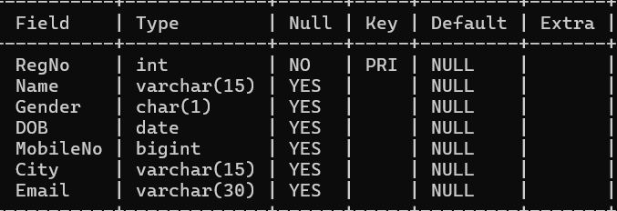
DESC STUDENT;

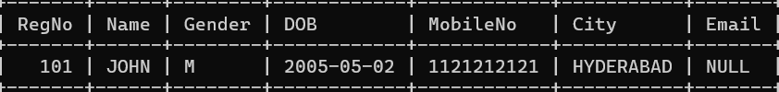
SELECT * FROM STUDENT;
TRUNCATE TABLE STUDENT;
Query OK, 0 rows affected (0.02 sec)
DROP TABLE STUDENT;
Query OK, 0 rows affected (0.01 sec)
SELECT * FROM STUDENT;
ERROR 1146 (42S02): Table 'practice.student' doesn't exist
Result : The STUDENT table was created successfully with the specified structure.

